**Homework 10**

**Instructions:** Do as many of the problems as you like, but make sure to complete at least **three**. Then I will create a solution from your work.

1. Solve the following quadratic congruences, if possible. If not possible, justify why.

For each of these we can use the quadratic formula (the slightly modified form of $x=(-b±\sqrt{b^{2}-4ac})(2a)^{-1}$)

a. $2x^{2}+3x+3≡0 (mod 17)$

* Using the above equation and $a, b, c = 2, 3, 3$ and simplifying we obtain $x≡(-3±\sqrt{2})(4^{-1}) (mod 17)$.
* By Euler's criterion we know that 2 has a square root modulo 17 because $2^{(17-1)/2}=2^{8}=2^{4}2^{4}=16⋅16≡(-1)(-1)≡1 (mod 17)$.
* Through guess-and-check we can determine that 6 is one of the square roots of 2 modulo 17.
* Additionally, $4⋅4≡-1 (mod 17)$ so $4⋅-4≡4⋅13≡1 (mod 17)$. This tells us that $4^{-1}≡13 (mod 17)$.
* Putting this all together and simplifying we obtain $x≡(-3±6)(13)≡2, 5 (mod 17)$

b. $3x^{2}+x+2≡0 (mod 17)$

* With the quadratic equation we obtain $x≡(-1±\sqrt{11})(6^{-1}) (mod 17)$.
* Using WolframAlpha we can find that $11^{8}≡16≡-1 (mod 17)$. Thus, by Euler's Criterion, 11 does not have a square root modulo 17.
* So no solution exists for the given congruence.

c. $3x^{2}+2x+1≡0 (mod 17)$

* With the quadratic equation we obtain $x≡(-2±\sqrt{9})(6^{-1}) (mod 17)$.
* Modulo 17, the square root of 9 is 3 because $3^{2}=9$ and the inverse of 6 is 3 because $6⋅3=18≡1 (mod 17)$.
* With these substitutions we obtain $x≡(-2±3)(3) ≡2, 3 (mod 17).$

1. Calculate  
   a. $\left(\frac{-144}{601}\right)= \left(\frac{-1}{601}\right)\left(\frac{144}{601}\right)$ The second term is 1 because 144 is a square and the first term is 1 because 601=1 (mod 4). So the final result is 1.

b. $\left(\frac{-1}{607}\right)$ This is equal to -1 because 607=3 (mod 4).  
  
c. $\left(\frac{425}{461}\right)=\left(\frac{-36}{461}\right)$ This is also equal to 1, using a similar process as in a.

* Since $425=25⋅17$, we can rewrite this as $(\frac{425}{461})=(\frac{25}{461})(\frac{17}{461})$.
* We know $5^{2}=25$ so $(\frac{25}{461})=1$ and so $(\frac{425}{461})=(\frac{17}{461})$.
* Using quadratic reciprocity we know $(\frac{17}{461})(\frac{461}{17})=(\frac{17}{461})(\frac{2}{17})=(-1)^{(16)(460)/4}$.
* We can easily see that $(-1)^{(16)(460)/4}=(-1)^{(4)(460)}=1$.
* Additionally, since $17≡1 (mod 8)$ then by Theorem 2 of the in class activity, $(\frac{2}{17})=1$.
* Thus, $(\frac{17}{461})(1)=1$ so $(\frac{17}{461})=1$ and $(\frac{425}{461})=1$.

1. Let $p>5$ be a prime number. Show that at least one of 2, 3, or 6 must be a quadratic residue modulo *p.*

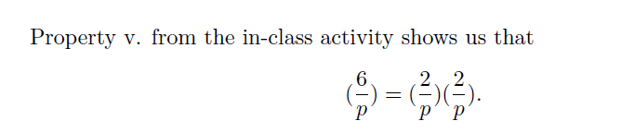

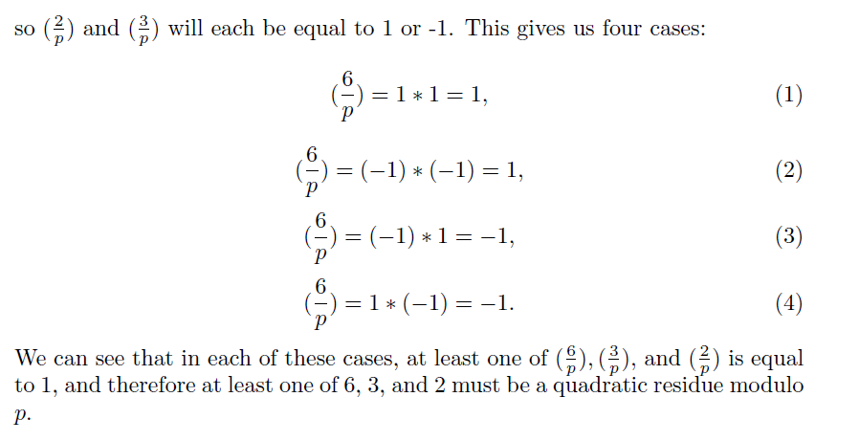

1. Let *p* be an odd prime and suppose that *a* is an element modulo *p* with odd order. Show that *a* is a quadratic residue. (Hint: Euler’s criterion)

* Let *g* be the order of *a*. By assumption *g* is odd. We know $g|ϕ(p)$ meaning $g|p-1$. Since *p* is odd, *p-1* is even. Since *g* is odd, this also means that $g|(p-1)/2$.
* Thus, since $a^{g}≡1 (mod p)$ by definition, we also know $a^{(p-1)/2}≡1 (mod p)$.
* Finally, by Euler's criterion this means $(\frac{a}{p})=1$ and $a$ is a quadratic residue modulo *p*.

1. Compute by hand $\left(\frac{8569}{8831}\right).$ (Hint: 8831 is prime and $8569=11⋅19⋅41.$)

$\left(\frac{8569}{8831}\right)= \left(\frac{11}{8831}\right)\left(\frac{19}{8831}\right)\left(\frac{41}{8831}\right)$

Using QR: $\left(\frac{11}{8831}\right)$ $\left(\frac{8831}{11}\right)= -1$

Note that the second term on the left hand side reduces to (9/11)=1 (9 is clearly a square), so the first term must be -1.

$\left(\frac{19}{8831}\right)$ $\left(\frac{8831}{19}\right)= -1$ as well.

The second term on the left reduces to (15/19), which is -1 because 15 is not a square mod 19 (trial-error, or 15^9=-1 (mod 19)). Therefore, the first term must be 1.

$\left(\frac{41}{8831}\right)$ $\left(\frac{8831}{41}\right)= 1$

The second term reduces to (16/41)=1, therefore the first term is 1 too.

This gives us

$\left(\frac{8569}{8831}\right)= \left(\frac{11}{8831}\right)\left(\frac{19}{8831}\right)\left(\frac{41}{8831}\right)= -1(1)(1)= -1.$

1. Let *p* be an odd prime not equal to 5. Show that $\left(\frac{5}{p}\right)=1$ if and only if $p≡±1 (mod 5).$

First, note that $p ≠0 (mod 5).$ Then by QR, if

$\left(\frac{5}{p}\right)\left(\frac{p}{5}\right)=(-1)^{(p-1)}= 1$

Therefore, $\left(\frac{5}{p}\right)$ is equal to $\left(\frac{p}{5}\right),$ and the latter is equal to 1 if and only if $p=1,4 (mod 5).$ This is the same condition as given in the problem statement.